Determination of characteristic variables of a power supply using the power transfer model.

Nathan Gillispie.

Lab Partner: Luke Alford

Date of experiment: October 6

# Abstract

Power transferred from a power supply varies by the effective resistance of the circuit connected to it. Data is collected by measuring the current and voltage across a decade resistor box and fit to a power transfer model. An equation for power as a function of resistance is used to calculate 1. characteristic variables of the power supply and 2. maximum power transferred. The maximum power output is found to be when the effective resistance of the circuit is equal to the internal resistance of the power supply.

# Introduction

A power supply is a complex device that can be effectively modeled using only two components: an electromotive force (ε) and internal resistor (r).

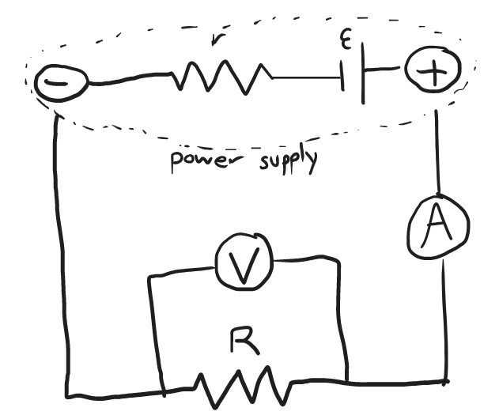

**Figure 1:** Connection diagram and modeled power supply.

Using the loop rule, we find that ε=IR+Ir. Applying Ohm’s law and rearranging, we get the linear relationship V=-Ir+ε. This means give a voltage vs current plot of a power supply, the negative slope is the internal resistance and the y-intercept is the electromotive force.

Using the loop rule on our circuit, the current becomes $I=\frac{ε}{r+R}$ and substituting current into the definition of power $P=I^{2}R$ we get the equation of power transfer:

$${P=ε}^{2}\frac{R}{{(r+R)}^{2}}$$

This assumes that the voltmeter has effectively infinite resistance and the ammeter has effectively no resistance. Since there are two ways of determining characteristic variables ε and r, these models can be compared.

# Method

A power supply, decade resistor box, ammeter and voltmeter are connected according to figure 1. The voltmeter was turned to the 2000mV setting and the ammeter was turned to the 200mA setting. The voltage was initially set to 0V and the resistor was set to 30Ω. The power supply was turned on and the voltage was slowly increased to 1000mV; this setting remained for the duration of the experiment. The following steps were repeated for resistances of 25Ω, 20Ω, 15Ω to 1Ω in increments of 1Ω for a total of 18 measurements. Ensuring the resistance never became 0Ω while the power was on, for the given resistance, the voltage and current were recorded. After all measurements were taken, the power was calculated according its definition $P=I^{2}R$.

The values were imported into physics data assistant to create a graph of voltage over current. A linear fit was performed to calculate the characteristic variables ε and r of the power supply. A second graph was constructed as power over resistance. A power transfer fit was applied to again calculate the characteristic variables. The values were compared to each other.

# Results and Data

**Table 1:** Data collected including power transfer calculation.

|  |  |  |  |
| --- | --- | --- | --- |
| **Voltage (V)** | **Current (A)** | **Resistance (Ω)** | **Power (W)** |
| 1.000 | 0.0318 | 30 | 0.030337 |
| 0.957 | 0.0366 | 25 | 0.033489 |
| 0.904 | 0.0428 | 20 | 0.036636 |
| 0.821 | 0.0533 | 15 | 0.042613 |
| 0.802 | 0.0558 | 14 | 0.043590 |
| 0.783 | 0.0583 | 13 | 0.044185 |
| 0.761 | 0.0613 | 12 | 0.045092 |
| 0.737 | 0.0646 | 11 | 0.045904 |
| 0.711 | 0.0683 | 10 | 0.046648 |
| 0.673 | 0.0737 | 9 | 0.048885 |
| 0.639 | 0.0786 | 8 | 0.049423 |
| 0.600 | 0.0842 | 7 | 0.049627 |
| 0.556 | 0.0908 | 6 | 0.049467 |
| 0.504 | 0.0984 | 5 | 0.048412 |
| 0.443 | 0.1078 | 4 | 0.046483 |
| 0.373 | 0.1186 | 3 | 0.042197 |
| 0.284 | 0.1324 | 2 | 0.035059 |
| 0.172 | 0.1496 | 1 | 0.022380 |

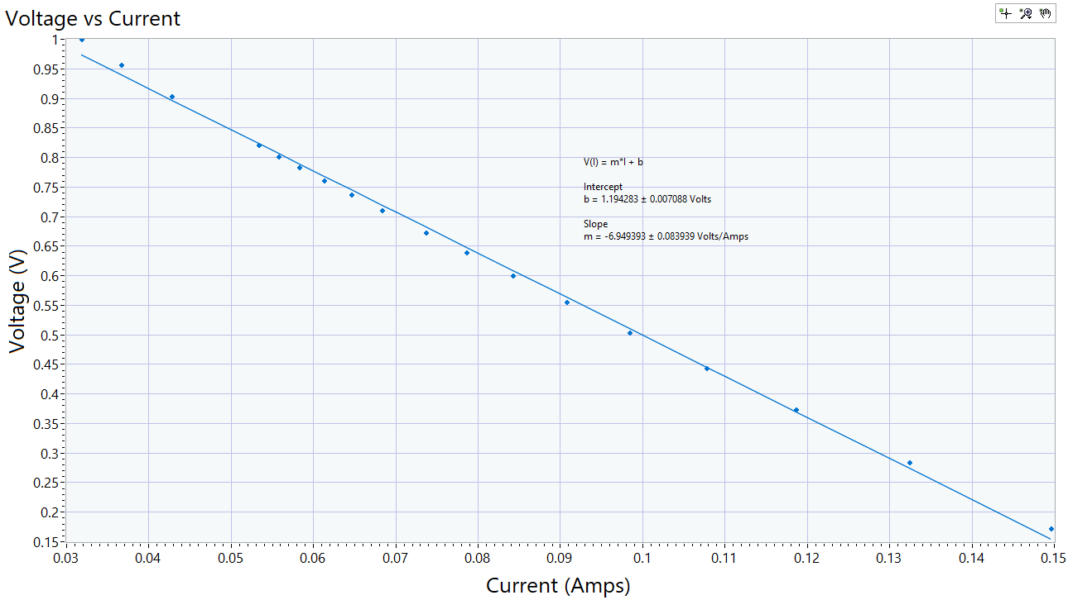

**Figure 2:** Voltage over Current plot with linear fit.

The linear fit calculated from physics data assistant included the slope and y-intercept with uncertainty. These values are the linear fit model internal resistance rL and electromotive force εL.

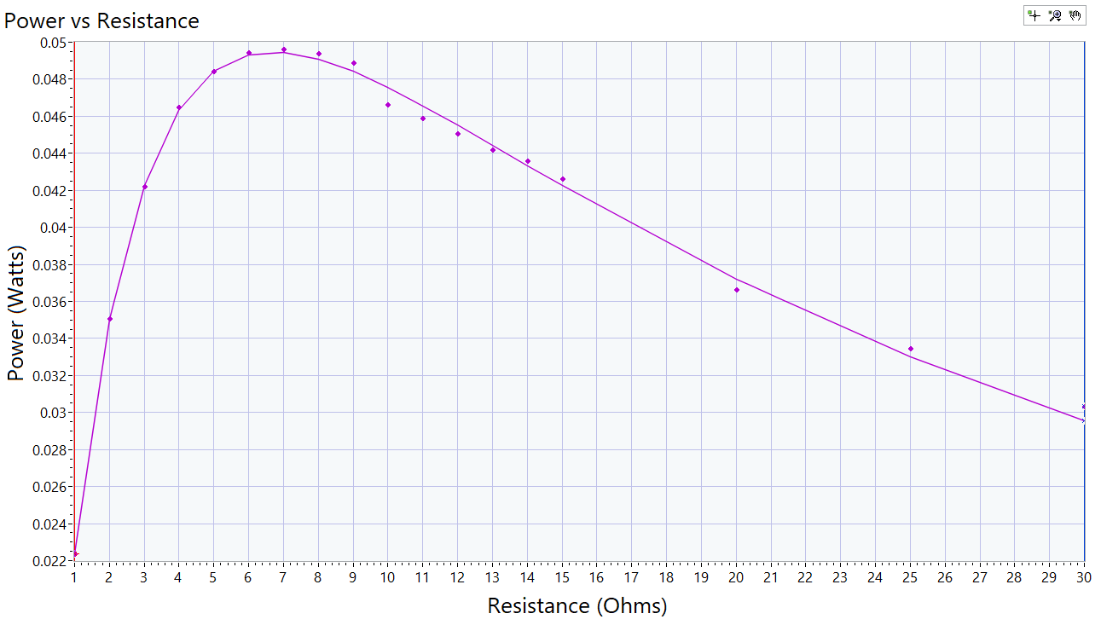

**Figure 3:** Power over resistance including power transfer model fit.

The power transfer fit produced different characteristic variables.

$$r_{P}=\left(6.707±0.056\right)Ω \\ ε_{P}=(1.202±0.0045)V$$

Notice how the peak power output is located at the internal resistance of the power supply. Now we can use the two standard error criteria to determine if the two pairs of characteristic variables agree. For the resistance:

$$r_{L}-2δr_{L}=6.781Ω<6.819Ω=r_{P}+2δr_{P}$$

So, the two values agree. For the electromotive force the values also agree:

$$ε_{L}+2δε_{L}=1.2085V>1.1930V=ε_{P}-2δε_{P}$$

# Conclusion

From the data collected, we found the internal resistance of the power supply to be around 6.8Ω. The electromotive force of the power supply when set to 1000mV was actually around 1200mV. This means the power peaked at around 0.05W at those settings. We noted that the transferred power peaked when the effective resistance of the circuit was the same as the internal resistance of the power supply. This was mathematically confirmed when finding the solution to the second derivative of the power with respect to resistance. Since the power transfer model and the linear model both agree in values, we have not disproven the assumptions made about the circuit. For example: the power supply can be modeled with an emf and resistor, the ammeter has effectively zero resistance, the voltmeter has effectively infinite resistance, all resistors were their stated resistance, all resistors are ohmic etc. When the mathematics aligns with reality, we know that the same models can be used in the future.